ASSIGNMENT 2
Student Activity Management System
Unit – Control Flow in Java | Individual Coding Assignment

Student Name | Sasanka Sekhar Kundu
Assignment | Assignment 2 – Student Activity Management System
Programming Language | Java
IDE Used | Visual Studio Code

1. Objective
The objective of this assignment is to implement a menu-driven Student Activity Management System using Java control-flow concepts. The program accepts attendance percentage and marks, validates the input, and provides options to check examination eligibility, view the student's performance category, or exit the application.

2. Problem Statement
Develop a Java program that uses Scanner for keyboard input, conditional statements for decision-making, a switch statement for menu selection, and loops for repeated interaction. The system must validate attendance and marks and display appropriate messages for valid and invalid input.

3. Concepts Used
- Scanner for user input
- if and if-else conditional statements
- Nested if statement
- switch statement
- while loop for repeated input and menu interaction
- break statement for exiting loops and switch cases
- continue statement for invalid menu input
- Input validation and error handling

4. Program Logic
The program first validates attendance so that it falls between 0 and 100. It then validates marks in the same range. After valid input is obtained, a repeating menu is displayed. Option 1 checks whether attendance is at least 75%. Option 2 categorizes marks as Excellent, Good, Average, or Needs Improvement. Option 3 terminates the program.

5. Performance Categories
Marks | Category
90–100 | Excellent
70–89 | Good
60–69 | Average
Below 60 | Needs Improvement

Attendance eligibility rule: 75% or above = Eligible; below 75% = Not eligible.

6. Complete Source Code
import java.util.Scanner;
public class StudentActivityManagementSystem {
public static void main(String[] args) {
Scanner scanner = new Scanner(System.in);
double attendance;
int marks;
// ===== Attendance Input =====
while (true) {
System.out.print("Enter attendance percentage (0-100): ");
if (scanner.hasNextDouble()) {
attendance = scanner.nextDouble();
if (attendance >= 0 && attendance <= 100) {
break;
} else {
System.out.println(
"Invalid attendance! Please enter a value between 0 and 100."
);
}
} else {
System.out.println(
"Invalid input! Please enter a numeric attendance percentage."
);
scanner.next();
}
}
// ===== Marks Input =====
while (true) {
System.out.print("Enter marks (0-100): ");
if (scanner.hasNextInt()) {
marks = scanner.nextInt();
if (marks >= 0 && marks <= 100) {
break;
} else {
System.out.println(
"Invalid marks! Please enter marks between 0 and 100."
);
}
} else {
System.out.println(
"Invalid input! Please enter numeric marks."
);
scanner.next();
}
}
// ===== Main Menu =====
while (true) {
System.out.println();
System.out.println(
"===== Student Activity Management System ====="
);
System.out.println();
System.out.println("1. Check Attendance Eligibility");
System.out.println("2. View Performance Category");
System.out.println("3. Exit");
System.out.println();
System.out.print("Enter your choice: ");
// Validate menu input
if (!scanner.hasNextInt()) {
System.out.println(
"Invalid input! Please enter 1, 2, or 3."
);
scanner.next();
continue;
}
int choice = scanner.nextInt();
switch (choice) {
case 1:
System.out.println();
System.out.println(
"===== Attendance Eligibility ====="
);
if (attendance >= 75) {
System.out.println("Attendance : " + attendance + "%");
System.out.println(
"Status : Eligible to appear for the examination."
);
} else {
System.out.println("Attendance : " + attendance + "%");
System.out.println(
"Status : Not eligible to appear for the examination."
);
}
break;
case 2:
System.out.println();
System.out.println(
"===== Performance Category ====="
);
System.out.println("Marks : " + marks);
if (marks >= 90) {
System.out.println("Category : Excellent");
} else if (marks >= 70) {
System.out.println("Category : Good");
} else if (marks >= 60) {
System.out.println("Category : Average");
} else {
// Nested if
if (marks < 60) {
System.out.println(
"Category : Needs Improvement"
);
}
}
break;
case 3:
System.out.println();
System.out.println(
"Thank you for using the Student Activity Management System."
);
System.out.println("Program exited successfully.");
scanner.close();
break;
default:
System.out.println();
System.out.println(
"Invalid menu choice! Please select 1, 2, or 3."
);
continue;
}
if (choice == 3) {
break;
}
}
}
}

7. Compilation and Execution
The program was compiled and executed successfully from the VS Code terminal using:
javac StudentActivityManagementSystem.java
java StudentActivityManagementSystem

8. Test Run / Output
For the demonstrated test run, attendance was entered as 45% and marks as 70. The program correctly reported that the student was not eligible for the examination, classified 70 marks as Good, repeatedly displayed the menu, and exited successfully when option 3 was selected.
Enter attendance percentage (0-100): 45
Enter marks (0-100): 70
===== Student Activity Management System =====
1. Check Attendance Eligibility
2. View Performance Category
3. Exit
Enter your choice: 1
===== Attendance Eligibility =====
Attendance : 45.0%
Status : Not eligible to appear for the examination.
===== Student Activity Management System =====
1. Check Attendance Eligibility
2. View Performance Category
3. Exit
Enter your choice: 2
===== Performance Category =====
Marks : 70
Category : Good
===== Student Activity Management System =====
1. Check Attendance Eligibility
2. View Performance Category
3. Exit
Enter your choice: 3
Thank you for using the Student Activity Management System.
Program exited successfully.

9. Execution Screenshot
The screenshot below shows the Java source code in Visual Studio Code and the successful terminal execution of the Student Activity Management System.
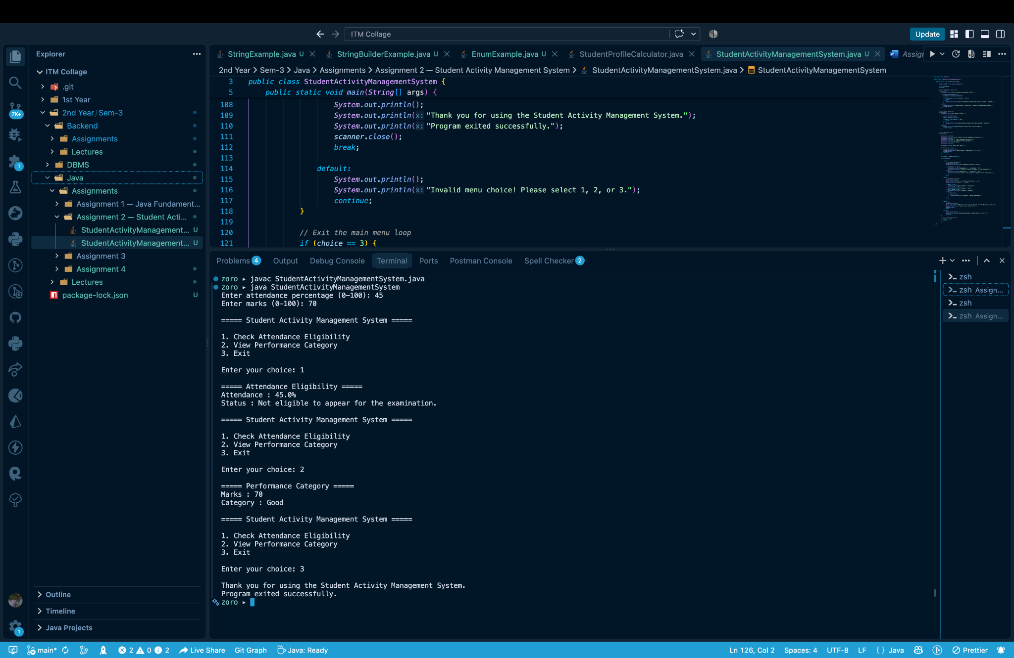

10. Result
The Student Activity Management System was successfully compiled and executed. The program accepted and validated attendance and marks, correctly checked attendance eligibility, classified the student's performance, displayed the menu repeatedly, handled menu selection using switch, and exited successfully using break.

11. Conclusion
This assignment provided practical experience with Java control-flow mechanisms. It demonstrated how loops, conditional statements, switch-case selection, break, continue, Scanner input, and input validation can be combined to build a simple interactive application. The successful test run confirms that the program meets the assignment requirements.
— End of Assignment 2 Report —

